INTEGRATE ZSCALER WITH IDENTITY PROVIDERS (IDPS) SUCH AS AZURE

STAGE-1
Title of the Project
Integrate Zscaler with Identity Providers (IdPs) such as Azure AD.
Overview
The project “Integrate Zscaler with Identity Providers such as Microsoft Azure Active Directory” focuses on improving secure user authentication and access management in modern cloud environments. Many organizations use multiple cloud applications and services, which makes identity management and network security very important. This project demonstrates how integrating Zscaler with Azure AD helps organizations manage user identities and provide secure access to applications through a centralized authentication system.
In this integration, Azure AD acts as the Identity Provider (IdP) that verifies user credentials and manages authentication. Once the user is authenticated, Zscaler enforces security policies and allows secure access to enterprise applications and internet services. The system uses technologies such as Single Sign-On (SSO) and Multi-Factor Authentication (MFA) to ensure that only authorized users can access organizational resources.
The integration also helps organizations improve network security by monitoring user activity, controlling access based on roles, and protecting systems from cyber threats such as unauthorized access, phishing attacks, and malware. Administrators can manage users, apply security policies, and monitor access from a centralized platform, which simplifies security management.
Overall, this project highlights the importance of combining cloud security with identity management. By integrating Zscaler with Azure AD, organizations can enhance security, improve user experience, and ensure safe access to enterprise resources in modern digital environments.
Overall, integrating Zscaler with Identity Providers like Microsoft Azure Active Directory enhances identity-based security, simplifies user authentication through Single Sign-On, and enables centralized identity management. This integration helps organizations build a secure and efficient cloud-based security architecture while ensuring seamless access for users.

LIST OF TEAMMATES:
S.NO | NAME | COLLEGE | CONTACT
1 | Vishali shree K Team leader | AVP College of Arts and Science | kvsm1807@gmail.com
2 | Karthika M | AVP College of Arts and Science | karthikamanoharan716@gmail.com
3 | Ramlath nisha K M | AVP College of Arts and Science | shifu8364@gmail.com
4 | Swetha M | AVP College of Arts and Science | swethamurugesan017@gmail.com
5 | Srinivi S | AVP College of Arts and Science | srinivisudhagar@gmail.com

LIST OF VULNERABILITY TABLE
S.no | Vulnerability Name | CWE/CVE - No
1 | Absolute Path Traversal | CWE-36: Absolute Path Traversal
2 | External Control of System or Configuration Setting | CWE-15: External Control of System or Configuration Setting
3 | Vulnerable and Outdated Components (Dependency Vulnerability) | CWE-1104: Use of Unmaintained Third-Party Components
4 | Key Management Errors | CWE-320 – Key Management Errors
5 | Command Injection | CWE-77: Improper Neutralization of Special Elements used in a Command
6 | Incorrect User Management / Improper User Role Assignment | CWE-286 – Incorrect User Management
7 | Improper Certificate Validation | CWE-295 – Improper Certificate Validation
8 | Uncontrolled Search Path Element | Uncontrolled Search Path Element
9 | Information Loss or Omission | Information Loss or Omission
10 | Uncaught Exception | CWE-248 – Uncaught Exception

REPORT:
1.Vulnerability Name:
Absolute Path Traversal
CWE/CVE:
CWE-36: Absolute Path Traversal
OWASP/SANS Category:
OWASP Top 10 – Broken Access Control
Description:
Absolute Path Traversal is a vulnerability that occurs when an application uses external user input to construct file paths without properly validating or sanitizing the input. Attackers can exploit this weakness by supplying absolute path sequences such as /etc/passwd or /abs/path, allowing them to access files and directories outside the intended restricted directory. This vulnerability enables unauthorized navigation of the file system, potentially exposing sensitive data or system resources that should not be accessible to the user.
Business Impact:
Vulnerability path: https://example.com/download?file=/etc/passwd
If this vulnerability is exploited, attackers may gain unauthorized access to confidential files, system configuration files, or application data stored on the server. This could lead to data leakage, system compromise, or modification of critical files, affecting the confidentiality, integrity, and availability of the organization’s systems. In severe cases, attackers may overwrite important files, bypass authentication mechanisms, or execute malicious code, resulting in service disruption, reputational damage, and potential financial loss for the organization.
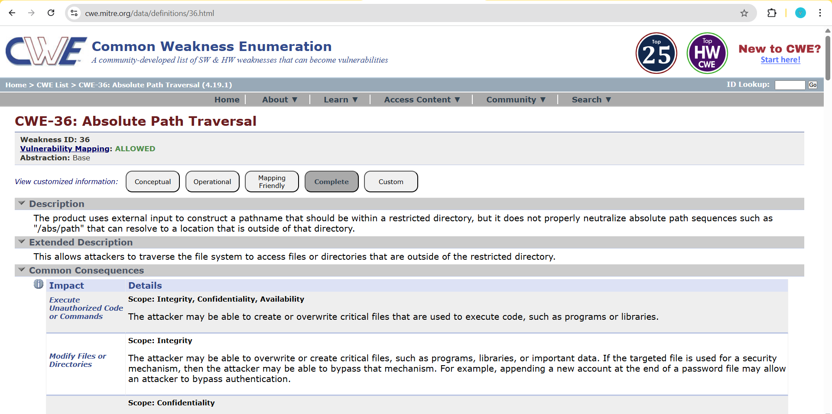

2. Vulnerability name:
External Control of System or Configuration Setting
CWE/CVE:
CWE-15: External Control of System or Configuration Setting
OWASP/SANS Category:
OWASP Top 10 – Security Misconfiguration
Description:
External Control of System or Configuration Setting is a vulnerability that occurs when an application allows external users or untrusted inputs to control system configuration settings. Normally, configuration settings determine how an application behaves, including security rules, file locations, authentication mechanisms, and system permissions. These settings are expected to be controlled only by trusted administrators or internal system processes.
However, when an application exposes configuration parameters to external input without proper validation or access control, attackers can manipulate these settings. By altering configuration values, attackers may force the system to behave in unexpected or malicious ways. For example, an attacker may change file paths, disable security features, modify environment variables, or redirect the system to load malicious resources.
This vulnerability typically occurs when developers allow configuration data to be read directly from user-controlled sources such as URL parameters, cookies, HTTP headers, environment variables, or external configuration files without verifying their integrity. As a result, attackers can influence how the application runs and potentially bypass important security mechanisms.
External Control of System or Configuration Setting is dangerous because configuration settings often control critical application behaviour, including logging mechanisms, authentication services, access permissions, and system resource management. If attackers gain the ability to manipulate these settings, they may be able to disrupt application functionality, bypass security controls, or gain unauthorized access to sensitive system components.
Business Impact:
If this vulnerability is exploited, attackers may manipulate system configurations to disrupt services, weaken security protections, or gain unauthorized system access. This can lead to application malfunction, data leakage, and unauthorized modification of system settings. In severe cases, attackers may disable security controls, redirect application behaviour, or execute malicious code through manipulated configurations. Such incidents can result in operational downtime, loss of sensitive data, reputational damage, and financial loss for the organization.
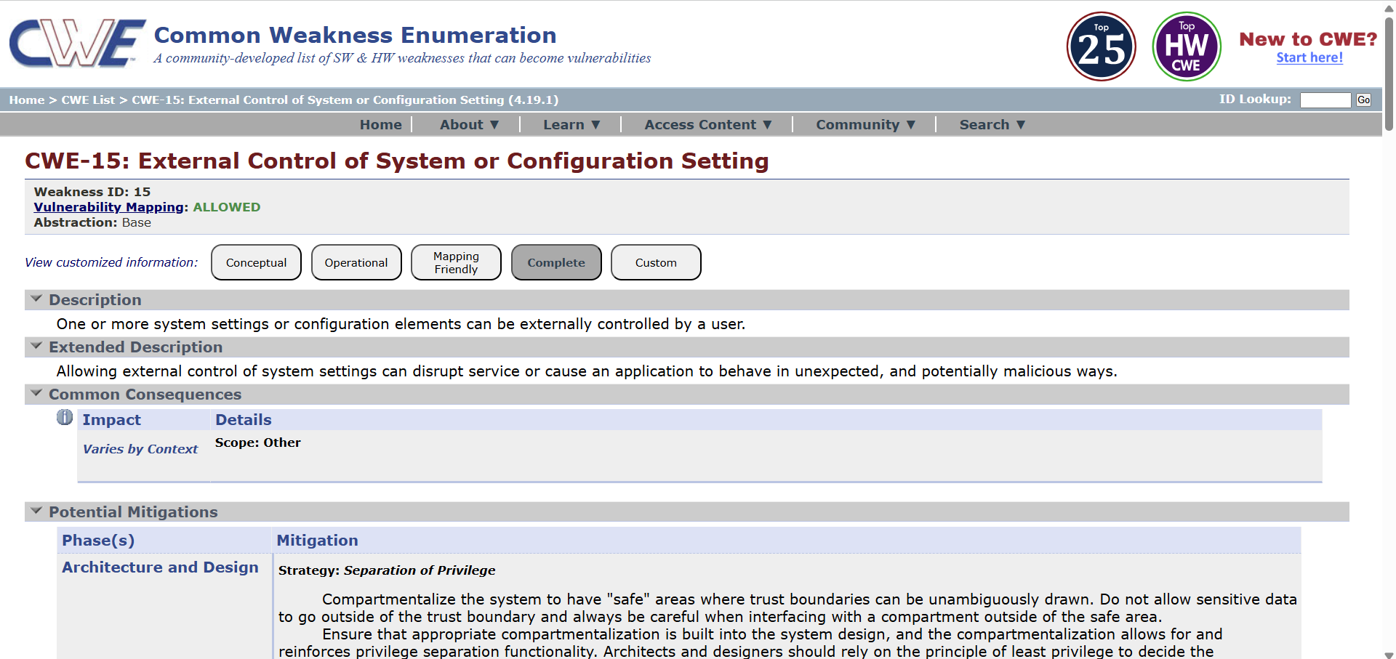

3. Vulnerability Name:
Vulnerable and Outdated Components (Dependency Vulnerability)
CWE/CVE:
CWE-1104: Use of Unmaintained Third-Party Components
OWASP/SANS Category:
OWASP Top 10 – A06: Vulnerable and Outdated Components
Description:
Vulnerable and Outdated Components is a security weakness that occurs when an application uses third-party libraries, frameworks, or software components that contain known vulnerabilities or are no longer maintained. Modern software applications heavily depend on external components such as open-source libraries, plugins, APIs, and frameworks to speed up development and provide additional functionality. However, if these components are outdated or contain known security flaws, they may introduce vulnerabilities into the application.
Attackers often scan applications to identify the versions of libraries or dependencies being used. If a known vulnerability exists in that component, attackers can exploit it to gain unauthorized access, execute malicious code, or disrupt system operations. Since these components are integrated directly into the application, any vulnerability present in them can affect the overall security of the system.
Tools like OWASP Dependency-Track help organizations analyze software components and detect vulnerabilities in dependencies using Software Bill of Materials (SBOM). By monitoring these dependencies, developers can identify outdated libraries and update them before attackers exploit them.
This vulnerability is particularly dangerous because many organizations are unaware of all the external components included in their applications. If components are not regularly monitored and updated, they can remain vulnerable for long periods and become easy targets for attackers.
Business Impact:
If vulnerable or outdated components are used in an application, attackers may exploit known security flaws to gain unauthorized access, execute malicious code, or compromise sensitive data. This can lead to data breaches, system downtime, service disruption, and loss of customer trust. Additionally, organizations may face financial losses, legal penalties, and reputational damage if exploited vulnerabilities result in the exposure of confidential information or disruption of business operations.

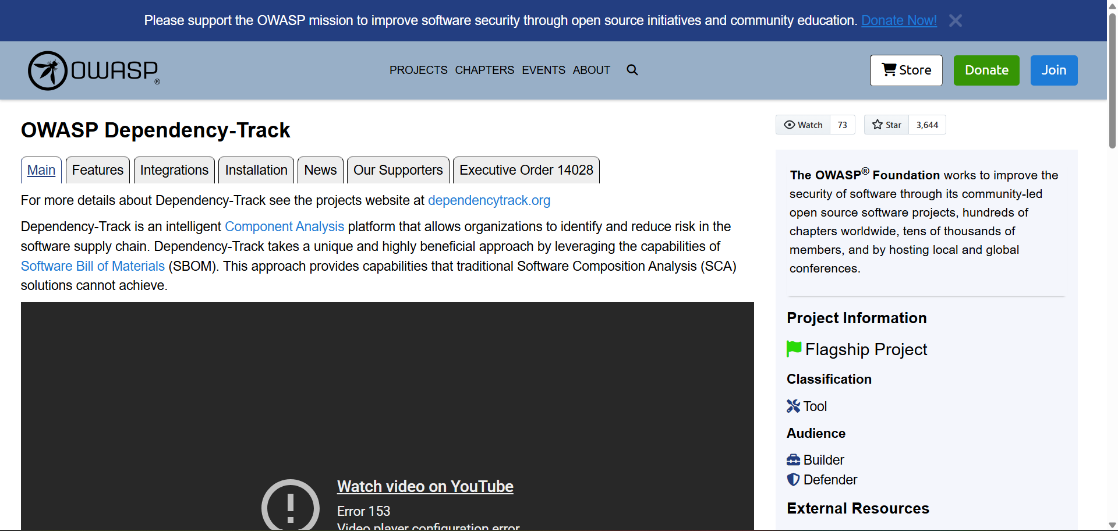

4. Vulnerability Name:
Key Management Errors
CWE/CVE:
CWE-320 – Key Management Errors
OWASP / SANS Category:
- OWASP Top 10: A02:2021 – Cryptographic Failures
- SANS Top 25: Use of Hard-coded Credentials / Improper Key Management
Description:
Key Management Errors occur when cryptographic keys are not securely generated, stored, distributed, rotated, or revoked within an application or system. Weak key management practices such as using hard-coded keys, reusing keys, failing to rotate keys regularly, or storing keys in insecure locations can compromise the effectiveness of cryptographic protections. If attackers gain access to these keys, they may be able to decrypt sensitive information, impersonate systems, or bypass security mechanisms.

Business Impact:
Improper key management can lead to the exposure of sensitive information such as passwords, financial records, and personal data if attackers obtain cryptographic keys. Compromised keys can allow attackers to decrypt confidential communications, forge authentication tokens, or impersonate trusted systems. This may result in data breaches, regulatory penalties, financial losses, and severe reputational damage to the organization.
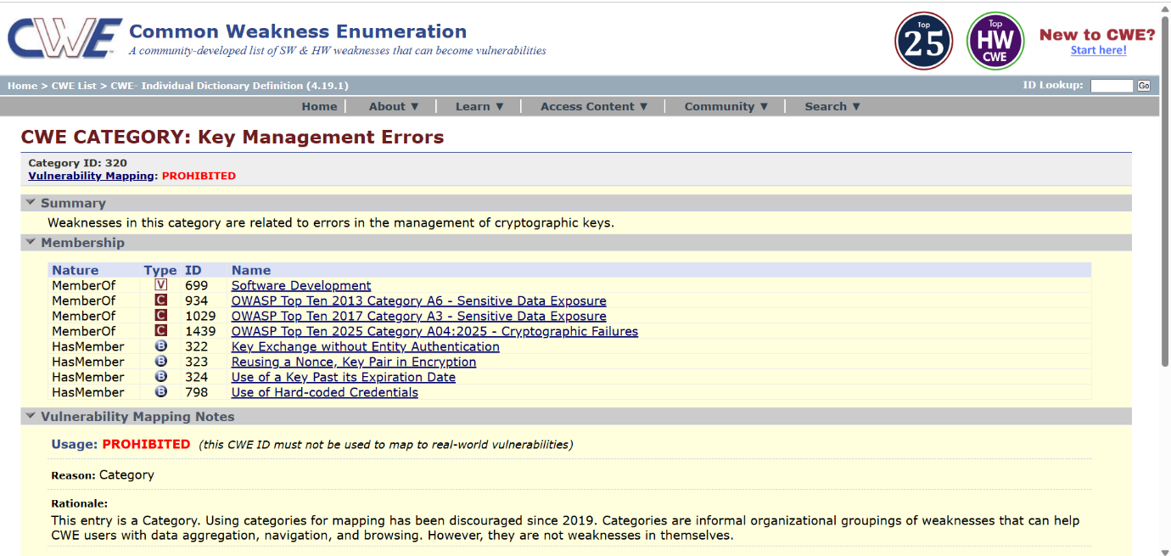
5. Vulnerability Name:
Command Injection
CWE/CVE:
CWE-77: Improper Neutralization of Special Elements used in a Command
OWASP/SANS Category:
OWASP Top 10 – A03: Injection
Description:
Command Injection occurs when an application constructs system commands using user-supplied input without properly validating or sanitizing the input. Attackers can insert malicious commands or special characters that are interpreted by the operating system.
When this happens, the attacker can manipulate the command execution process and run unauthorized commands on the server. This vulnerability usually appears in applications that use functions to execute system-level commands such as shell scripts, operating system commands, or external programs.
For example, if an application executes a system command like ping or ls using user input without validation, an attacker may append additional commands (such as; rm -rf /) which the system will execute.
Business Impact:
Command Injection is considered a critical vulnerability because it can lead to severe consequences:
- Unauthorized execution of system commands
- Full system compromise by attackers
- Data theft or modification
- Server takeover or remote control
- Service disruption or denial of service
- Exposure of sensitive system information
These impacts can damage the organization’s reputation and may lead to financial and legal consequences.

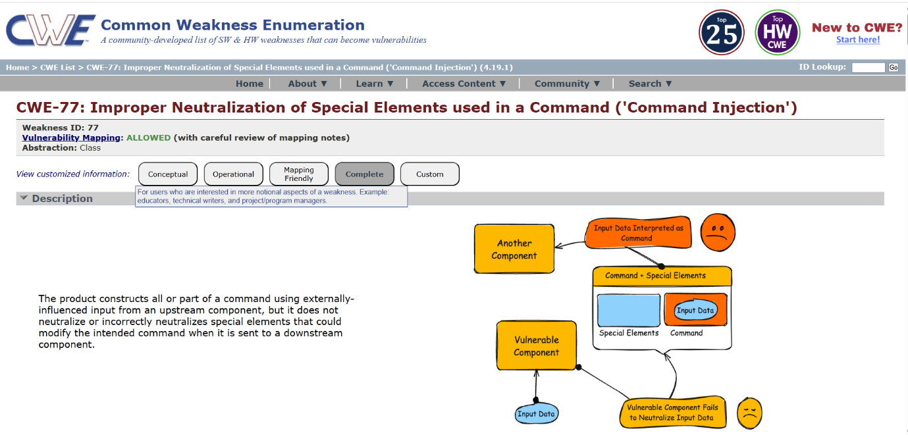

6. Vulnerability Name:
Incorrect User Management / Improper User Role Assignment
CWE/CVE:
CWE-286 – Incorrect User Management
OWASP / SANS Category:
- OWASP Top 10: Broken Access Control (A01:2021)
- SANS Top 25: Improper Access Control
Description:
Incorrect User Management occurs when an application fails to properly manage users, roles, or permission assignments. This can happen when users are placed in incorrect groups, given excessive privileges, or when role validation is not properly enforced. As a result, users may gain unauthorized access to sensitive resources, functions, or data within the system.
Business Impact:
If incorrect user management exists in an application, users may be assigned to inappropriate roles or permission groups, allowing them to access sensitive information or perform actions beyond their authorized privileges. This can lead to unauthorized disclosure, modification, or deletion of critical data. Attackers or malicious insiders may exploit this weakness to escalate privileges, gain administrative access, or bypass security controls. As a result, the organization may face financial losses, legal and regulatory penalties, operational disruption, and reputational damage due to compromised data confidentiality, integrity, and availability.
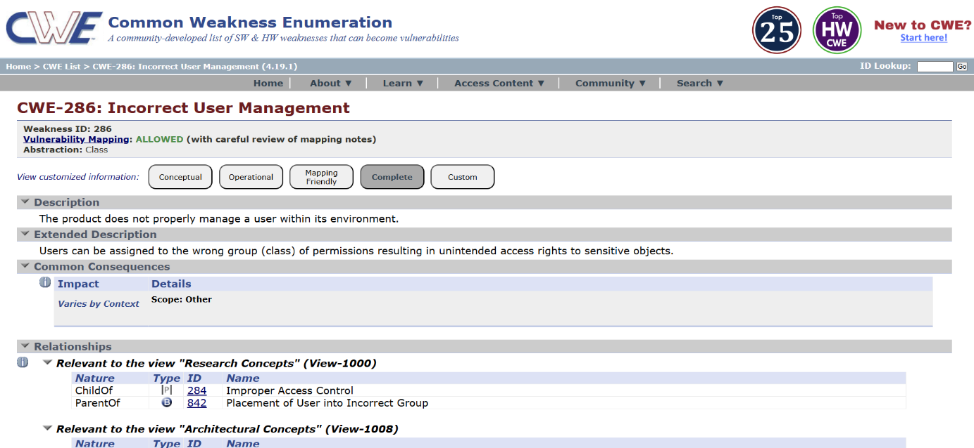
7. Vulnerability Name:
Improper Certificate Validation
CWE/CVE:
CWE-295 – Improper Certificate Validation
OWASP / SANS Category:
- OWASP Top 10: A02:2021 – Cryptographic Failures
- SANS Top 25: Improper Certificate Validation / Improper Authentication
Description:
Improper Certificate Validation occurs when an application fails to properly verify the authenticity and validity of SSL/TLS certificates during secure communications. This can happen if the application does not check the certificate authority (CA), hostname, expiration date, or trust chain correctly. As a result, the application may accept invalid, self-signed, or malicious certificates, allowing attackers to intercept or manipulate encrypted communications.
Business Impact:
If certificate validation is not properly implemented, attackers may perform Man-in-the-Middle (MitM) attacks to intercept, monitor, or modify sensitive communications between users and servers. This can lead to the exposure of confidential data such as login credentials, financial information, or personal records. Compromised communication channels can result in data breaches, loss of customer trust, regulatory penalties, and financial or reputational damage to the organization.

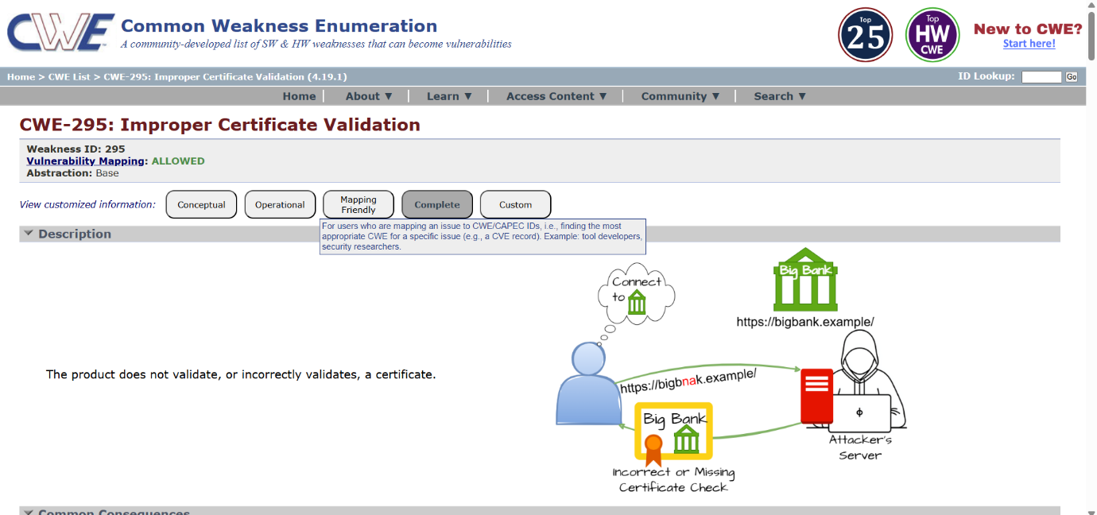
8. Vulnerability Name:
Uncontrolled Search Path Element
CWE/CVE:
CWE-427 – Uncontrolled Search Path Element
OWASP / SANS Category:
- OWASP Top 10: A05:2021 – Security Misconfiguration
- SANS Top 25: Uncontrolled Search Path Element
Description:
Uncontrolled Search Path Element occurs when an application relies on a search path to locate executable, libraries, or resources, but one or more directories in that path can be modified or controlled by untrusted users. If the application loads resources without specifying a fully qualified path, attackers may place malicious files in these directories. As a result, the application may load and execute the attacker’s malicious code instead of the legitimate resource.
Business Impact:
If this vulnerability is exploited, attackers may execute malicious code within the application’s environment by placing crafted files or libraries in directories that are searched by the system. This can lead to unauthorized code execution, system compromise, data theft, or privilege escalation. Such attacks may disrupt business operations, compromise sensitive systems, and cause financial losses and reputational damage to the organization.

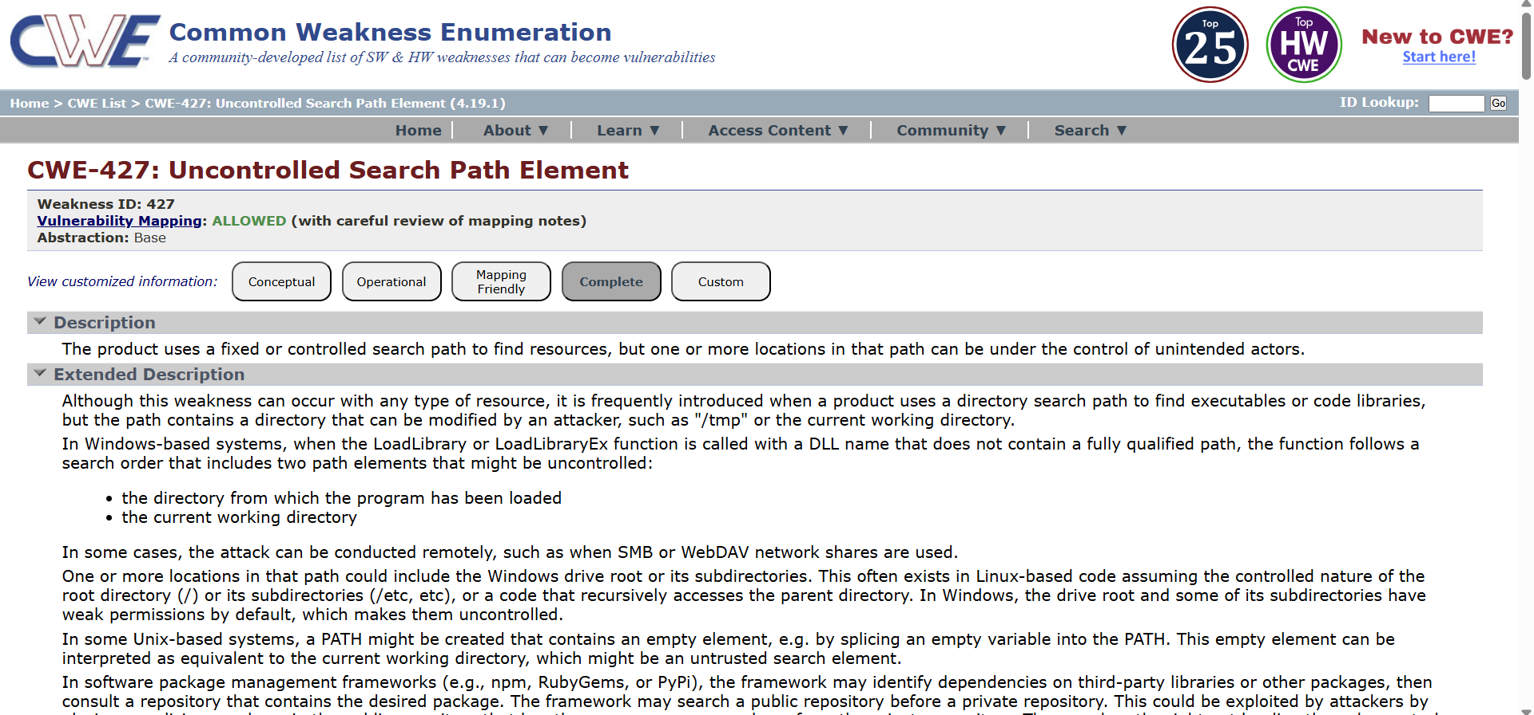
9. Vulnerability Name:
Information Loss or Omission
CWE/CVE:
CWE-221 – Information Loss or Omission
OWASP / SANS Category:
- OWASP Top 10: A09:2021 – Security Logging and Monitoring Failures
- SANS Top 25: Improper Handling of Security-Relevant Information
Description:
Information Loss or Omission occurs when a system fails to record, logs incorrectly, or omits important security-relevant information during operations. This may include incomplete logging of authentication events, missing audit trails, or improper recording of errors and security activities. As a result, security teams may not have sufficient information to detect suspicious activities, investigate incidents, or make accurate security decisions.
Business Impact:
If security-relevant information is not properly recorded or is omitted from logs, organizations may be unable to detect unauthorized activities, investigate security incidents, or perform effective forensic analysis. This lack of visibility can allow attackers to remain undetected within the system for extended periods. Additionally, incomplete audit trails can lead to compliance violations, operational risks, and reputational damage, as organizations may fail to demonstrate accountability and traceability during security investigations.

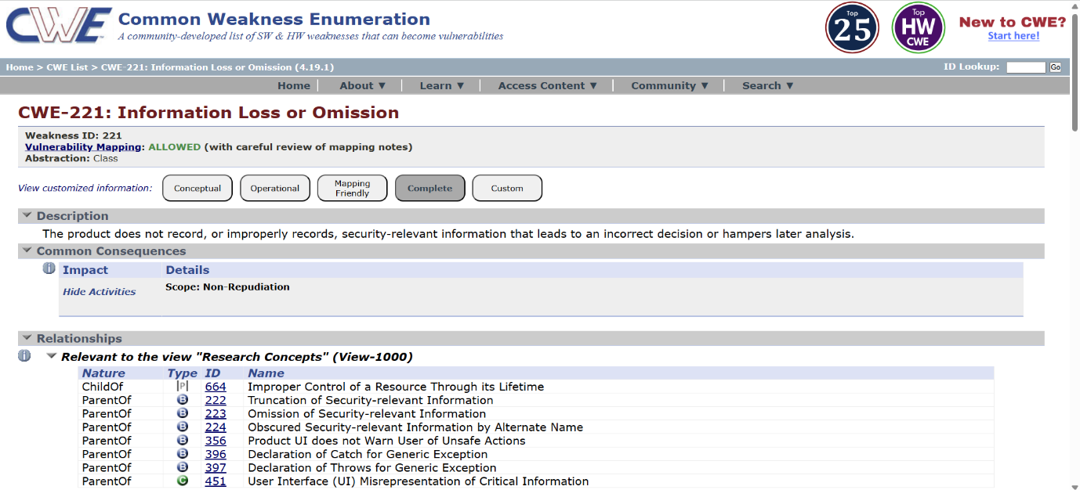
10.Vulnerability Name:
Uncaught Exception
CWE/CVE:
CWE-248 – Uncaught Exception
OWASP / SANS Category:
- OWASP Top 10: A09:2021 – Security Logging and Monitoring Failures
- SANS Top 25: Improper Handling of Exceptional Conditions
Description:
Uncaught Exception occurs when an application throws an exception or error during execution but fails to properly handle it using appropriate exception handling mechanisms. When exceptions are not caught, the application may crash, terminate unexpectedly, or expose internal system information such as stack traces, file paths, or configuration details. This can provide attackers with useful information about the system and its internal workings.
Business Impact:
If exceptions are not properly handled, the application may crash or become unavailable, resulting in service disruption and poor user experience. Additionally, unhandled exceptions may expose sensitive system information that attackers can use to identify vulnerabilities and plan further attacks. This can lead to information disclosure, reduced system availability, security risks, and potential reputational and financial damage to the organization.

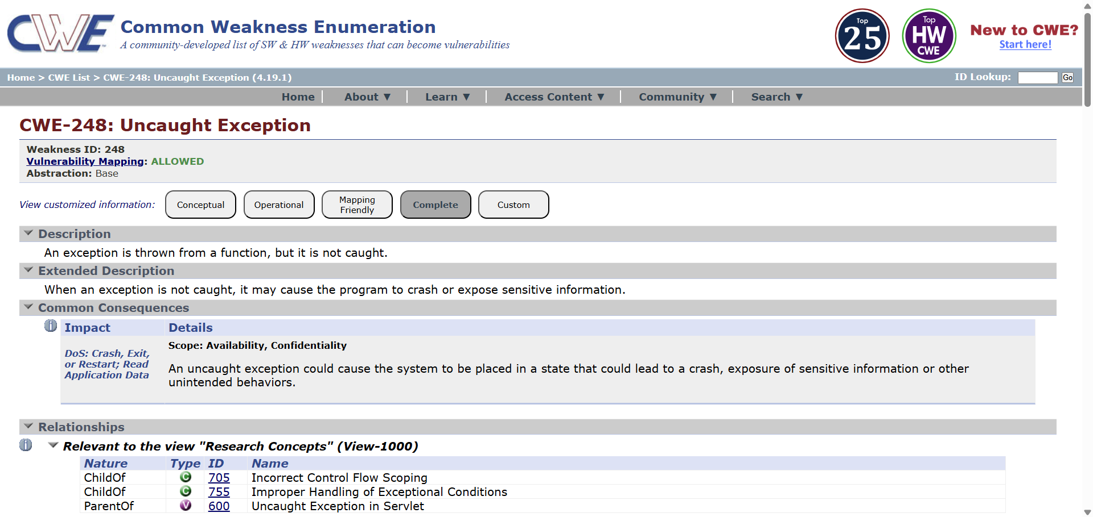
STAGE 2
Overview:
Nessus is one of the most commonly used vulnerability scanning tools developed by Tenable. It is created to assist security professionals in detecting vulnerabilities, security configuration issues, and possible threats that exist in computer systems, networks, and web applications. Nessus is considered a remote vulnerability scanner, meaning it does not require installation on the target machine. Instead, the scanner analyzes the target system from another device by sending different types of probes and evaluating the responses it receives.
The Nessus scanner operates by transmitting multiple kinds of requests to the target host in order to collect system information. These probes can include network traffic queries, operating system level commands, and application-level requests. By analysing the responses returned from the target system, Nessus identifies potential security weaknesses and vulnerabilities. This scanning process enables security administrators to detect issues such as outdated software versions, insecure system configurations, open network ports, and missing security updates.
One of the key characteristics of Nessus is its plugin-based framework. Plugins are small modules that are specifically created to detect particular vulnerabilities. Nessus contains an extensive collection of plugins that are frequently updated to identify newly discovered security threats. Each plugin is designed to examine a specific vulnerability in operating systems, applications, or network services. During a scan, Nessus executes numerous plugins to inspect the target system and discover possible vulnerabilities.
During the vulnerability assessment process, Nessus initially performs a discovery stage where it gathers details about the target system such as the operating system type, open ports, and active services. After collecting this information, Nessus launches various vulnerability detection plugins to check whether the system contains known security weaknesses. Once the scanning procedure is completed, Nessus produces a comprehensive vulnerability report that includes the severity level of each issue, an explanation of the vulnerability, potential risks involved, and recommended solutions to resolve the problem.
Nessus can scan a wide variety of targets including individual computers, entire network infrastructures, and web applications. Security administrators can configure the scanner to examine specific IP addresses, domain names, ports, or particular services. The scanning activity can be executed manually or scheduled to run automatically at predefined intervals. This capability makes Nessus a useful solution for ongoing security monitoring.
The vulnerability results generated by Nessus are classified into several severity categories such as Critical, High, Medium, Low, and Informational. This classification allows security teams to prioritize which vulnerabilities must be addressed first. By discovering and fixing these weaknesses at an early stage, organizations can minimize the chances of cyber-attacks and improve their overall security strength.
Overall, Nessus is a highly effective and dependable vulnerability assessment tool that plays a crucial role in protecting modern IT environments. It enables organizations to proactively identify and fix security weaknesses before attackers have the opportunity to exploit them.
Target Website: http://zero.webappsecurity.com/
Target IP Address: 54.82.22.214
List of vulnerability:
S.No. | Vulnerability name | Severity | plugins
1 | SSL Version 2 and 3 Protocol Detection | Critical | 20007
2 | OpenSSL SSL_OP_NETSCAPE_REUSE_ CIPHER_CHANGE_BUG Session Resume Ciphersuite Downgrade Issue | Medium | 51892
3 | Apache Tomcat 7.0.0 < 7.0.82 | High | 103782
4 | SSL Weak Cipher Suites Supported | Medium | 26928
5 | SSL/TLS Diffie-Hellman Modulus <= 1024 Bits (Logjam) | Low | 83875
6 | JQuery 1.2 < 3.5.0 Multiple XSS | Medium | 136929
7 | SSL Medium Strength Cipher Suites Supported (SWEET32) | High | 42873
8 | SSL/TLS EXPORT_RSA <= 512-bit Cipher Suites Supported (FREAK) | Medium | 81606
9 | Additional DNS Hostnames | Info | 46180
10 | SSLv3 Padding Oracle on Downgraded Legacy Encryption Vulnerability (POODLE) | Low | 78479

REPORT:
1. Vulnerability Name: SSL Version 2 and 3 Protocol Detection
Severity: Critical
Plugin: 20007
Port: 443 / tcp
Description:
The remote service accepts connections encrypted using SSL 2.0 and/or SSL 3.0. These versions of SSL are affected by several cryptographic flaws, including:
- An insecure padding scheme with CBC ciphers.
-Insecure session renegotiation and resumption schemes.
An attacker can exploit these flaws to conduct man-in-the-middle attacks or to decrypt communications between the affected service and clients.
Although SSL/TLS has a secure means for choosing the highest supported version of the protocol (so that these versions will be used only if the client or server support nothing better), many web browsers implement this in an unsafe way that allows an attacker to downgrade a connection (such as in POODLE). Therefore, it is recommended that these protocols be disabled entirely.
NIST has determined that SSL 3.0 is no longer acceptable for secure communications. As of the date of enforcement found in PCI DSS v3.1, any version of SSL will not meet the PCI SSC's definition of 'strong cryptography'.
Solution :
Consult the application's documentation to disable SSL 2.0 and 3.0.
Use TLS 1.2 (with approved cipher suites) or higher instead.
Business Impact :
The use of outdated protocols such as SSL 2.0 and SSL 3.0 can expose the organization to serious security risks. Attackers may exploit these weaknesses to perform Man-in-the-Middle attacks and intercept encrypted communications between the server and clients. This can lead to the exposure of sensitive information such as login credentials, financial data, and customer details. If such data is compromised, it may result in data breaches and loss of customer trust. The organization could also face financial losses due to incident response, recovery efforts, and potential downtime. Additionally, using insecure SSL protocols may cause non-compliance with security standards like PCI DSS, which requires strong cryptography. Non-compliance may lead to regulatory penalties and legal issues. Overall, this vulnerability can damage the organization’s reputation and negatively affect business operations and customer confidence.
2. Vulnerability Name: OpenSSL SSL_OP_NETSCAPE_REUSE CIPHER_CHANGE_BUG Session Resume Ciphersuite Downgrade Issue
Severity: Medium
Plugin: 51892
Port: 443 / tcp
Description:
The version of OpenSSL on the remote host has been shown to allow resuming session with a weaker cipher than was used when the session was initiated. This means that an attacker that sees (i.e., by sniffing) the start of an SSL connection can manipulate the OpenSSL session cache to cause subsequent resumptions of that session to use a weaker cipher chosen by the attacker.
Note that other SSL implementations may also be affected by this vulnerability.
Solution:
Upgrade to OpenSSL 0.9.8q / 1.0.0.c or later, or contact your vendor for a patch.
Business Impact:
The presence of this vulnerability in the OpenSSL library may allow attackers to force the system to resume SSL sessions using weaker encryption ciphers. This downgrade in encryption strength can reduce the overall security of the communication channel between the server and clients. An attacker who is able to monitor network traffic may manipulate the SSL session cache and influence the cipher used during session resumption. As a result, sensitive information transmitted over the connection may become easier to intercept or decrypt. This could potentially expose confidential business data, user credentials, or customer information. Such security weaknesses may increase the risk of data breaches and unauthorized access. If exploited, it can affect the organization’s ability to maintain secure communications and protect sensitive information. Ultimately, this may lead to reputational damage, loss of customer trust, and additional costs related to security remediation and monitoring.
03. Vulnerability Name: Apache Tomcat 7.0.0 < 7.0.82
Severity: High
Plugin: 103782
Port: 80 / tcp / www
Description:
The version of Tomcat installed on the remote host is prior to 7.0.82. It is, therefore, affected by a vulnerability as referenced in the fixed_in_apache_tomcat_7.0.82_security-7 advisory.
- When running Apache Tomcat versions 9.0.0.M1 to 9.0.0, 8.5.0 to 8.5.22, 8.0.0.RC1 to 8.0.46 and 7.0.0 to 7.0.81 with HTTP PUTs enabled (e.g. via setting the readonly initialisation parameter of the Default servlet to false) it was possible to upload a JSP file to the server via a specially crafted request. This JSP could then be requested and any code it contained would be executed by the server. (CVE-2017-12617)
Note that Nessus has not tested for this issue but has instead relied only on the application's self-reported version number.
Solution:
Upgrade to Apache Tomcat version 7.0.82 or later.
Business Impact:
The use of an outdated version of Apache Tomcat can expose the organization’s web server to serious security threats. Attackers may exploit this vulnerability to upload malicious JSP files to the server through specially crafted HTTP requests. Once uploaded, the malicious code could be executed on the server, potentially giving attackers unauthorized control over the application environment. This may lead to unauthorized access to sensitive data, system manipulation, or disruption of web services. If exploited, it could result in data breaches affecting customer or business information. Such incidents may cause service downtime and negatively impact normal business operations. Additionally, the organization could face financial losses due to recovery efforts and security incident management. Overall, this vulnerability can harm the organization’s reputation, reduce customer trust, and create compliance and legal risks.
04. Vulnerability Name: SSL Weak Cipher Suites Supported
Severity: Medium
Plugin: 26928
Port: 443 / tcp
Description:
The remote host supports the use of SSL ciphers that offer weak encryption.
Note: This is considerably easier to exploit if the attacker is on the same physical network.
Solution:
Reconfigure the affected application, if possible, to avoid the use of weak ciphers.
Business Impact :
The use of weak encryption cipher suites in SSL communication can reduce the overall security of data transmitted between the server and clients. Attackers may exploit these weak ciphers to intercept and potentially decrypt sensitive information during transmission. If an attacker is present on the same network, the risk of exploiting this vulnerability becomes significantly higher. Sensitive data such as login credentials, customer information, and business data could be exposed. This may lead to unauthorized access, data leakage, and possible security breaches. Such incidents can negatively affect the organization’s ability to maintain secure communications. Additionally, it may result in loss of customer trust and reputational damage. Addressing weak cipher suites is important to ensure strong encryption and protect critical business information.
05. Vulnerability Name: SSL/TLS Diffie-Hellman Modulus <= 1024 Bits (Logjam)
Severity: Low
Plugin: 83875
Port: 443 / tcp
Description:
The remote host allows SSL/TLS connections with one or more Diffie-Hellman moduli less than or equal to 1024 bits. Through cryptanalysis, a third party may be able to find the shared secret in a short amount of time (depending on modulus size and attacker resources). This may allow an attacker to recover the plaintext or potentially violate the integrity of connections.
Solution:
Reconfigure the service to use a unique Diffie-Hellman moduli of 2048 bits or greater.
Business Impact :
The use of weak Diffie-Hellman parameters with modulus sizes less than or equal to 1024 bits can reduce the strength of SSL/TLS encryption used to protect communications. Attackers with sufficient computational resources may exploit this weakness to perform cryptographic attacks and potentially discover the shared secret used in the connection. If successful, they may be able to decrypt sensitive information transmitted between the server and clients. This could expose confidential data such as login credentials, personal information, or internal business communications. Although the severity is low, it still weakens the overall security posture of the organization’s network. Over time, attackers may combine this weakness with other vulnerabilities to increase the impact of an attack. If exploited, it may affect the confidentiality and integrity of secure communications. Therefore, improving encryption strength is important to maintain secure and reliable business operations.
06. Vulnerability Name: JQuery 1.2 < 3.5.0 Multiple XSS
severity : Medium
Plugin : 136929
Port : 80 / tcp / www , 8080 / tcp / www
Description :
According to the self-reported version in the script, the version of JQuery hosted on the remote web server is greater than or equal to 1.2 and prior to 3.5.0. It is, therefore, affected by multiple cross site scripting vulnerabilities.
Note, the vulnerabilities referenced in this plugin have no security impact on PAN-OS, and/or the scenarios required for successful exploitation do not exist on devices running a PAN-OS release.
Solution :
Upgrade to JQuery version 3.5.0 or later.
Business Impact :
The use of an outdated version of jQuery may expose the web application to multiple Cross-Site Scripting (XSS) vulnerabilities. Attackers can exploit these weaknesses to inject malicious scripts into web pages viewed by users. When executed, these scripts may steal sensitive information such as user session cookies, login credentials, or personal data. This could allow attackers to impersonate legitimate users and gain unauthorized access to the system. Exploitation of XSS vulnerabilities can also lead to manipulation of web content or redirection of users to malicious websites. Such incidents may affect the reliability and trustworthiness of the organization’s web applications. Over time, this can result in loss of customer confidence and potential reputational damage. Therefore, keeping web application libraries updated is important to maintain a secure and stable user experience.
07. Vulnerability Name : SSL Medium Strength Cipher Suites Supported (SWEET32)
severity : High
Plugin : 42873
Port : 443 / tcp
Description :
The remote host supports the use of SSL ciphers that offer medium strength encryption. Nessus regards medium strength as any encryption that uses key lengths at least 64 bits and less than 112 bits, or else that uses the 3DES encryption suite.
Note that it is considerably easier to circumvent medium strength encryption if the attacker is on the same physical network.
Solution :
Reconfigure the affected application, if possible, to avoid use of medium strength ciphers.
Business Impact :
The use of medium strength SSL cipher suites can weaken the security of encrypted communications between the server and its users. These ciphers, including the 3DES encryption suite, are vulnerable to attacks such as SWEET32, which exploit weaknesses in block cipher algorithms. Attackers may take advantage of this vulnerability to intercept and analyze encrypted network traffic. Over time, this could allow them to decrypt sensitive information transmitted between clients and the server. Confidential data such as user credentials, financial information, or internal communications may be exposed. If attackers are present on the same network, the chances of successfully exploiting this vulnerability become higher. Such incidents may result in data breaches, service disruption, and potential financial losses. Overall, the presence of medium strength cipher suites can reduce the organization’s security posture and negatively impact customer trust and business reputation.
08. Vulnerability Name : SSL/TLS EXPORT_RSA <= 512-bit Cipher Suites Supported (FREAK)
severity : Medium
Plugin : 81606
Port : 443 / tcp
Description :
The remote host supports EXPORT_RSA cipher suites with keys less than or equal to 512 bits. An attacker can factor a 512-bit RSA modulus in a short amount of time.
A man-in-the middle attacker may be able to downgrade the session to use EXPORT_RSA cipher suites (e.g. CVE-2015-0204). Thus, it is recommended to remove support for weak cipher suites.
Solution :
Reconfigure the service to remove support for EXPORT_RSA cipher suites.
Business Impact :
The support for weak EXPORT_RSA cipher suites with key sizes of 512 bits or less can significantly reduce the security of SSL/TLS communications. Attackers may exploit this vulnerability through a downgrade attack to force the connection to use weak encryption, commonly known as the FREAK attack. Once the connection is downgraded, attackers may be able to break the encryption and decrypt sensitive data exchanged between the client and server. This could expose confidential information such as login credentials, personal data, or business communications. If exploited, attackers may also perform man-in-the-middle attacks to intercept or modify transmitted data. Such security weaknesses increase the risk of data breaches and unauthorized access to systems. These incidents may lead to operational disruption, financial losses, and recovery costs. Overall, this vulnerability can negatively impact the organization’s security posture, reputation, and customer trust.
09. Vulnerability Name : Additional DNS Hostnames
severity : Info
Plugin : 46180
Port : N/A
Description :
Hostnames different from the current hostname have been collected by miscellaneous plugins. Nessus has generated a list of hostnames that point to the remote host. Note that these are only the alternate hostnames for vhosts discovered on a web server. Different web servers may be hosted on name-based virtual hosts.
Solution :
If you want to test them, re-scan using the special vhost syntax, such as : www.example.com[192.0.32.10]
Business Impact :
This finding indicates that additional DNS hostnames are associated with the same server. These alternate hostnames may point to the same IP address and could host different web applications or services through virtual hosting. If these hostnames are not properly monitored or secured, they may expose additional entry points for attackers. Unmanaged or forgotten hostnames could run outdated applications or misconfigured services. This may increase the attack surface of the organization’s network infrastructure. Attackers could use this information to perform further reconnaissance and identify potential vulnerabilities. If exploited, it may lead to unauthorized access to certain web services or data. Properly identifying and managing all associated hostnames helps maintain better visibility and security control. Overall, monitoring DNS hostnames is important to ensure that all publicly accessible services are properly secured and maintained.
10. Vulnerability Name : SSLv3 Padding Oracle on Downgraded Legacy Encryption Vulnerability (POODLE)
severity : Low
Plugin : 78479
Port : 443 / tcp
Description :
The remote host is affected by a man-in-the-middle (MitM) information disclosure vulnerability known as POODLE. The vulnerability is due to the way SSL 3.0 handles padding bytes when decrypting messages encrypted using block ciphers in cipher block chaining (CBC) mode.
MitM attackers can decrypt a selected byte of a cipher text in as few as 256 tries if they are able to force a victim application to repeatedly send the same data over newly created SSL 3.0 connections.
As long as a client and service both support SSLv3, a connection can be 'rolled back' to SSLv3, even if TLSv1 or newer is supported by the client and service.
The TLS Fallback SCSV mechanism prevents 'version rollback' attacks without impacting legacy clients; however, it can only protect connections when the client and service support the mechanism. Sites that cannot disable SSLv3 immediately should enable this mechanism.
This is a vulnerability in the SSLv3 specification, not in any particular SSL implementation. Disabling SSLv3 is the only way to completely mitigate the vulnerability.
Solution : Disable SSLv3.
Services that must support SSLv3 should enable the TLS Fallback SCSV mechanism until SSLv3 can be disabled.
Business Impact :
The presence of the POODLE vulnerability due to the use of SSL 3.0 can expose encrypted communications to security risks. Attackers performing a Man-in-the-Middle attack may exploit this weakness to decrypt small portions of encrypted data during repeated SSL connections. Over time, this may allow attackers to recover sensitive information such as session cookies, authentication tokens, or user credentials. If these details are compromised, attackers could gain unauthorized access to user accounts or web applications. This vulnerability can weaken the confidentiality of data exchanged between clients and the server. Although exploitation requires specific conditions, it still increases the potential risk to secure communications. If left unaddressed, it may affect the overall trust users place in the organization’s online services. Therefore, disabling SSLv3 is important to ensure stronger encryption and maintain secure business operations.

Stage 3
Security Operations Center (SOC)
A Security Operations Center (SOC) is a centralized unit responsible for monitoring, detecting, and responding to cybersecurity threats within an organization. The SOC team continuously observes network activity, analyzes system logs, and investigates suspicious events to ensure the safety of digital resources. In modern cloud environments, organizations use advanced security platforms such as Zscaler integrated with identity providers like Azure Active Directory to strengthen authentication and access control. By monitoring authentication activities and network behavior, SOC teams can quickly detect unauthorized access attempts and respond effectively to security incidents.
SOC Cycle
The SOC cycle represents the continuous process followed by security teams to maintain cybersecurity. It generally consists of several stages including monitoring, detection, investigation, response, and recovery. First, security monitoring tools collect logs and security events from different sources such as servers, applications, and authentication systems. Next, these events are analyzed to detect abnormal behavior or potential security threats. Once a threat is identified, the SOC team investigates the incident and takes necessary action to mitigate the risk. Finally, the system is restored to normal operation and improvements are made to prevent similar incidents in the future.
Security Information and Event Management (SIEM)
Security Information and Event Management (SIEM) is a technology used to collect, analyze, and manage security data from multiple systems within a network. SIEM tools gather logs from servers, firewalls, applications, and authentication systems to detect suspicious activities. In this project, SIEM solutions help monitor authentication events generated when users access applications through Zscaler and Azure Active Directory. By analyzing these logs in real time, organizations can quickly identify potential cyber threats and take appropriate action to prevent security breaches.
SIEM Cycle
The SIEM cycle involves several important stages such as log collection, data normalization, correlation, analysis, and alert generation. First, logs from different systems and network devices are collected and stored in a centralized location. These logs are then standardized to ensure consistency for analysis. Correlation rules are applied to identify patterns or suspicious activities within the collected data. If abnormal behavior is detected, the SIEM system generates alerts that notify the security team. The security analysts then investigate the alert and respond accordingly to mitigate potential threats.
Malware Information Sharing Platform (MISP)
MISP is an open-source threat intelligence platform that allows organizations to share and receive information about cyber threats. It helps security teams collect data about malware, vulnerabilities, and attack patterns from different sources. By using threat intelligence provided by MISP, organizations can identify emerging threats and strengthen their defense mechanisms. This information helps security analysts detect malicious activities earlier and improve the overall security posture of the organization.
College Network Information
The college network infrastructure consists of multiple computers, servers, and networking devices such as routers and switches connected through a local area network. Students, faculty members, and administrative staff use this network for academic activities, accessing learning resources, and managing institutional data. Since the network contains sensitive information such as student records and internal documents, it is important to implement strong security measures. Integrating secure authentication mechanisms and monitoring systems can help protect the network from cyber threats.
How SOC Can Be Deployed in the College Network
A Security Operations Center can be deployed in the college network to monitor and protect digital infrastructure. Security monitoring tools can collect logs from servers, authentication systems, and network devices. These logs can be analyzed using SIEM platforms to detect suspicious activities. By integrating Zscaler with Azure Active Directory, user authentication can be centrally managed and monitored. If any abnormal behavior is detected, the SOC team can immediately investigate the issue and take appropriate actions to prevent security incidents. This approach helps improve network security and protects sensitive institutional data.

Threat Intelligence
Threat intelligence refers to the collection and analysis of information related to potential cyber threats and vulnerabilities. Security teams use threat intelligence to understand attack patterns, identify malicious activities, and strengthen security defenses. Threat intelligence data may include information about malware, phishing attacks, malicious IP addresses, and vulnerability exploits. By analyzing this information, organizations can anticipate potential cyber threats and implement preventive measures to reduce security risks.
Incident Response
Incident response is the process of identifying, managing, and resolving cybersecurity incidents within an organization. When a security alert is generated, the incident response team investigates the issue to determine its impact and severity. The response process typically includes identifying the threat, containing the attack, removing malicious components, and restoring the system to normal operation. Effective incident response helps organizations minimize damage caused by cyberattacks and ensures quick recovery of affected systems.
QRadar and Understanding the Tool
IBM QRadar is a widely used SIEM platform that provides advanced security monitoring and threat detection capabilities. It collects security logs from various systems and analyzes them using correlation rules and analytics techniques. QRadar helps security teams detect suspicious activities and respond to threats in real time. The dashboard provides a clear view of security events, enabling analysts to investigate incidents efficiently. By using QRadar, organizations can improve their ability to detect and respond to cybersecurity threats.

Conclusion
Stage 1
Stage 1 focused on understanding the concept of integrating Zscaler with identity providers such as Azure Active Directory. It helped in learning about secure authentication methods and identifying potential security vulnerabilities in modern cloud environments.
Stage 2
Stage 2 explored vulnerability assessment techniques and security scanning tools used to detect weaknesses in systems and networks.
Stage 3
Stage 3 focused on advanced cybersecurity concepts such as SOC, SIEM, threat intelligence, and incident response. These technologies help organizations monitor network activities, detect cyber threats, and respond to security incidents effectively. Implementing these systems improves overall network security and ensures better protection of digital resources.
Future Scope
Stage 1
In the future, the integration of Zscaler with identity providers can be expanded to include additional authentication platforms and advanced security mechanisms. Automated vulnerability assessment tools can also be implemented to identify potential security risks more effectively.
Stage 2
Future improvements may involve using multiple vulnerability scanning tools and automated security testing techniques to enhance system security.
Stage 3
Future improvements can include the use of Artificial Intelligence and Machine Learning technologies for advanced threat detection and automated incident response. Integrating additional security monitoring tools and expanding the SOC infrastructure will further strengthen the cybersecurity capabilities of the organization.

Topics Explored
- Cloud Security
- Identity Provider Integration
- Security Operations Center
- SIEM Monitoring
- Threat Intelligence
- Incident Response

Tools Explored
- Zscaler
- Microsoft Azure Active Directory
- IBM QRadar
- MISP Threat Intelligence Platform

